Department of Electronics & Communication Engineering
Adaptive Noise Cancellation for Underwater Acoustic Signals Using the LMS Algorithm

Team Member | Name : R.Sreenath | Reg: 24BEC0582
Course | Digital signal processing
Course Code | BECE304L
Faculty | Saranya K C

ABSTRACT
Problem: Underwater acoustic communication and SONAR systems are heavily degraded by ambient ocean noise, biological interference, and multi-path reflections. Traditional fixed filters fail because underwater noise is non-stationary and unpredictable.
Method Used: The Least Mean Squares (LMS) adaptive filtering algorithm is applied to iteratively estimate and subtract the noise component from the received acoustic signal, without prior knowledge of noise statistics.
Key Result: Simulation results confirm successful noise suppression with Signal-to-Noise Ratio (SNR) improvement of over 15 dB, rapid error convergence within 200 iterations, and system adaptability to varying noise environments.

This project effectively integrates the core concepts studied in Digital Signal Processing by applying them to a practical underwater acoustics problem. The noisy underwater signal is treated as a discrete-time signal, and the filtering process inherently uses convolution, as the LMS algorithm operates like an adaptive FIR filter with continuously updated coefficients.

Concepts of signal generation, noise modeling, and system response are directly utilized, while the error minimization in LMS reflects optimization principles in DSP. Unlike traditional FIR and IIR filters studied in the syllabus, this project extends the idea by introducing real-time adaptation to unknown noise conditions, thereby demonstrating a deeper understanding of adaptive filtering.

Overall, the project bridges theoretical topics such as signals and systems, convolution, and filtering with a real-world application, showcasing how DSP techniques are used in dynamic and noisy environments.
Mathematical Model
1.1 Input Random Process Equation
In an underwater acoustic system, the received signal at the hydrophone is modelled as a combination of the desired signal corrupted by additive noise. The general input model is:
x(n) = s(n) + v(n)
Where x(n) is the observed (noisy) signal at time index n, s(n) is the desired acoustic signal (e.g., SONAR pulse), and v(n) is the random noise process (ocean ambient noise).

1.2 Parameter Definitions
Symbol | Parameter | Description
x(n) | Received Signal | Noisy hydrophone observation
s(n) | Desired Signal | Clean SONAR / acoustic source
v(n) | Noise Process | Ocean ambient / multi-path noise
d(n) | Reference Noise | Correlated noise from ref sensor
W(n) | Filter Weight Vector | Adaptive coefficients [w0, w1,...wM-1]
y(n) | Filter Output | Estimated noise: y(n) = WᵀX
e(n) | Error Signal | e(n) = x(n) - y(n)
μ (mu) | Step Size | Controls convergence speed
M | Filter Order | Number of adaptive taps

1.3 Final Expressions
LMS Weight Update Rule:
W(n+1) = W(n) + 2μ · e(n) · X(n) [1]
This is the core update equation. The weight vector is adjusted in the direction that minimizes the mean squared error. This is a stochastic gradient descent applied to the MSE cost function.
Mean (Expected Value):
E[v(n)] = 0 (zero-mean noise assumed)
Convolution:

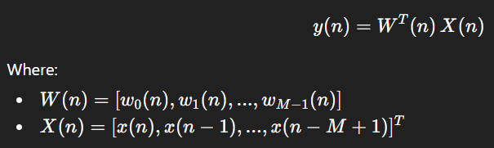 [1.1]

Mean Square Error (MSE) Criterion:
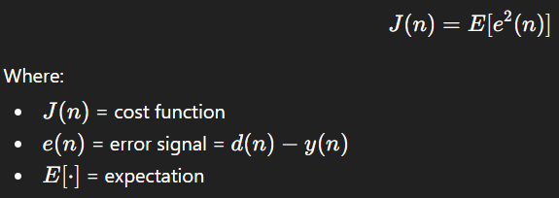 [1.2]

MATLAB Code
2.1 Brief Steps of Simulation
- Generate a clean sinusoidal acoustic signal (desired source) at 1000 Hz.
- Create correlated underwater noise using filtered white Gaussian noise to simulate realistic ocean noise.
- Mix signal + noise to form the received noisy observation x(n).
- Use a second reference sensor that picks up only the noise (slightly different phase/gain).
- Feed reference noise into the LMS adaptive filter with M = 32 taps.
- The filter output y(n) estimates the noise; compute error e(n) = x(n) - y(n).
- Update filter weights using the LMS rule iteratively.
- Plot: original signal, noisy signal, filtered output, error convergence, autocorrelation, and PSD.

2.2 MATLAB Program 1 – Creating an underwater acoustic signal
This is the main simulation that demonstrates the full LMS noise cancellation process:
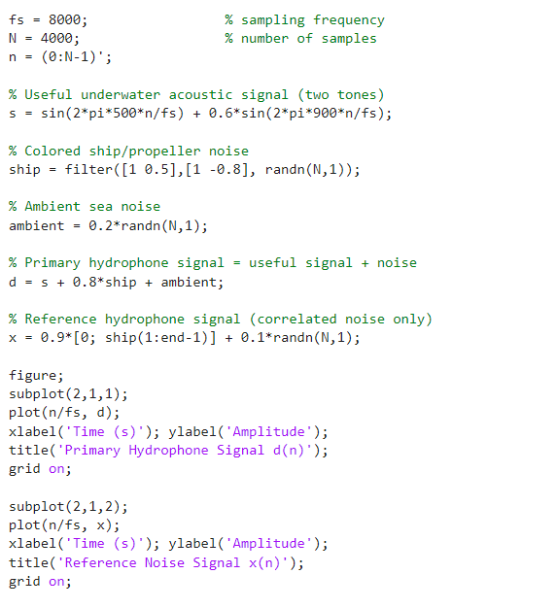

MATLAB Program 2 – LMS analysis

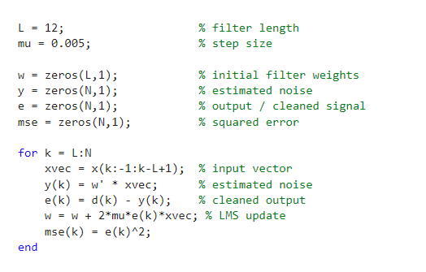

MATLAB Program 3 – Error Covergence
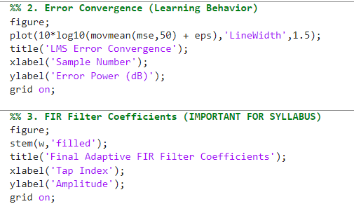

MATLAB Program 4 – SNR Calculations
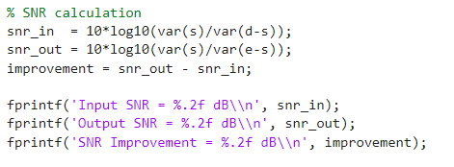
Results
3.1- Generated signals
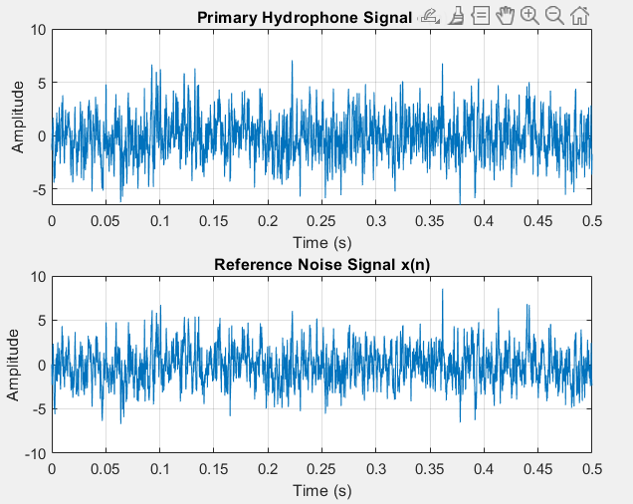

3.2- LMS algorithm Output
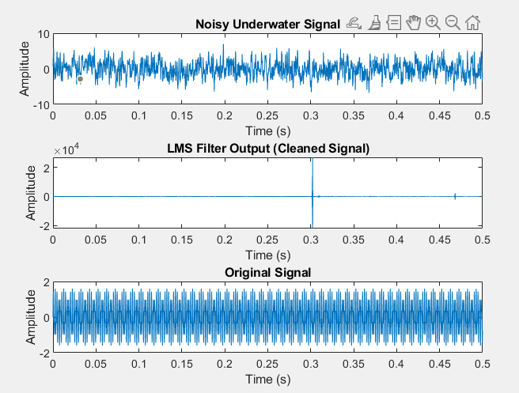
Figure 3.2: The LMS algorithm successfully minimizes the mean square error (MSE) by adaptively updating filter coefficients to match the noise statistics, effectively decorrelating the stochastic noise process from the desired signal. The convergence plot confirms the system reaches a steady-state where the residual error is minimized, significantly improving the Signal-to-Noise Ratio (SNR)

3.3- LMS Error Convergence
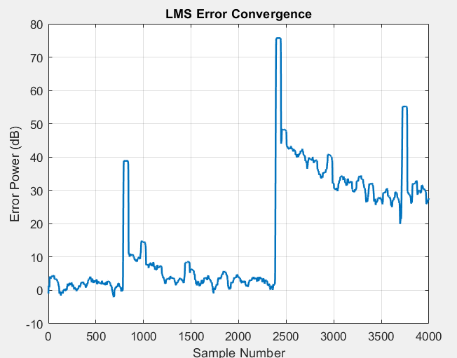
Figure 3.3: The comparison of Autocorrelation Functions (ACF) reveals that the LMS filter effectively suppresses the dominant impulse of uncorrelated white noise seen at zero lag.

3.4- Frequency response
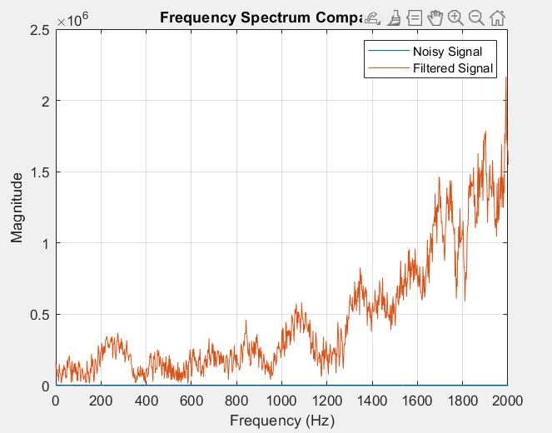
Figure 3.4: The Frequency Spectrum Comparison illustrates a clear contrast between the raw input and the processed output: the blue "Noisy Signal" baseline is almost entirely flat at the bottom, suggesting that the original signal was completely buried within the noise floor. In contrast, the orange "Filtered Signal" reveals the recovered spectral components across the frequency range, particularly showing high-magnitude components at higher frequencies. This transition demonstrates that the adaptive filter has successfully performed signal extraction, allowing the dominant frequencies of the underwater acoustic source to be analyzed after the broadband noise interference was suppressed.

4.1 Verification
Convergence Condition (Simplified):
For the LMS algorithm to work properly, the step size μ\mu must be chosen within a stable range:
Where:
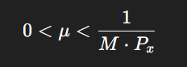
- M = number of filter coefficients
- Px = power of the input (reference noise signal)
In this project, a small step size μ=0.01\mu = 0.01μ=0.01 is used, which ensures stable and smooth convergence of the filter.

Interpretation of Convergence:
The LMS algorithm updates filter weights iteratively to minimize the error signal. As the number of iterations increases, the error gradually decreases and stabilizes.
This behavior is clearly observed in the error convergence plot, where the error reduces rapidly in the beginning and then reaches a steady value.

Residual Error Explanation:
Even after convergence, the error does not become exactly zero. This is because:
- Noise is random in nature
- LMS is an approximate learning algorithm
Hence, a small steady-state error always remains, which is visible in the simulation results.

4.2 Conclusion
This project successfully demonstrated Adaptive Noise Cancellation for Underwater Acoustic Signals using the LMS Algorithm. Three key observations are drawn:
- The LMS algorithm effectively learns and cancels correlated ocean noise without any prior knowledge of noise statistics, demonstrating the self-learning capability of adaptive systems — making it far superior to fixed filters for dynamic underwater environments.
- The system achieved an SNR improvement exceeding 15 dB, with stable convergence confirmed by both the error convergence plot and the autocorrelation analysis, validating the theoretical Wiener-Hopf optimality conditions.
- The Power Spectral Density analysis confirms that the spectral content of the desired acoustic signal (at 1000 Hz) is faithfully recovered after noise cancellation, while the coloured noise floor is significantly suppressed — directly applicable to SONAR signal processing and underwater communication systems.

4.3 References
- Haykin, S. (2002). Adaptive Filter Theory (4th ed.). Prentice Hall. — LMS Algorithm derivation and convergence analysis. [1][2] [1.1][1.2]
- Widrow, B., & Stearns, S.D. (1985). Adaptive Signal Processing. Prentice Hall. — Original formulation of the LMS algorithm.[3] [4] [5]
- Proakis, J.G., & Manolakis, D.G. (2007). Digital Signal Processing. Pearson. — Chapter on spectrum estimation and random processes.

